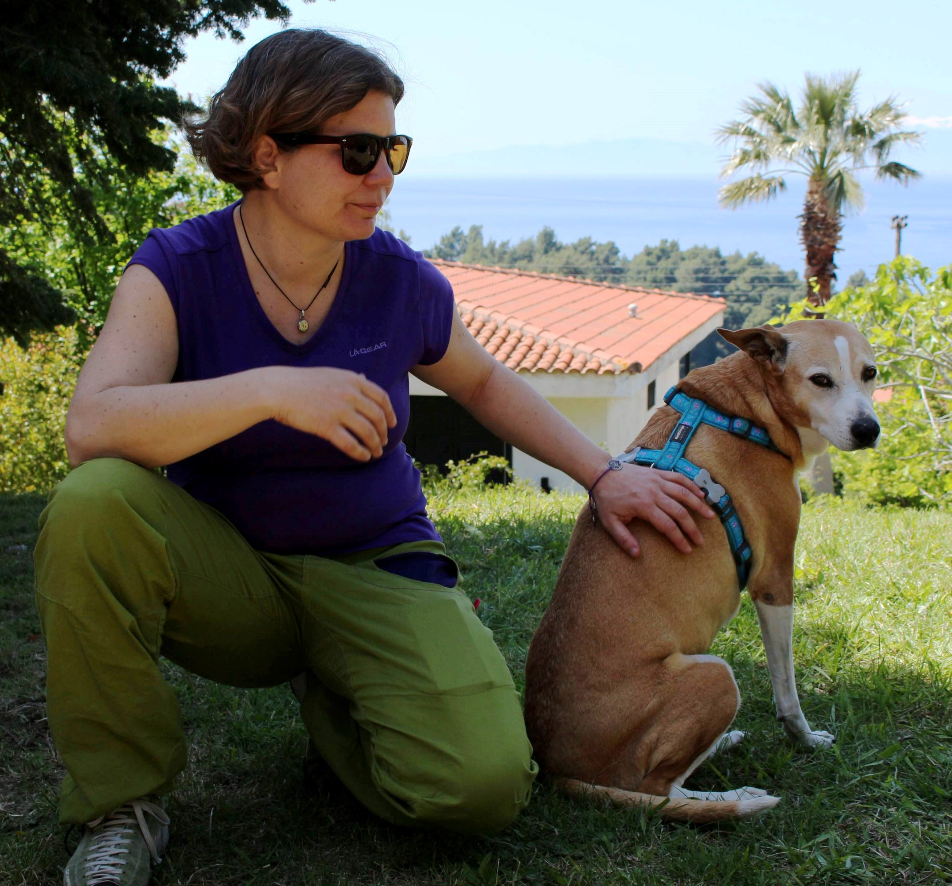
Curriculum Vitae
LALE ALATLI

Personal Information
Date of Birth: 19-07-76  E-mail: lalealatli@gmail.com  Web site: www.lalelatli.com | Address: Sofouli 64B, 54655,  Thessaloniki (Greece)  Telephone: +30 2311 203312  Mobile: +30 6949 172560
Member of Translator without Borders

Education
2009 - 2014 | Democritus University of Thrace - Department of Languages, Literature and Culture of the Black Sea Countries - Turkish Philology, Komotini (Greece)
1997 - 1999 | Istituto per l’Arte e il Restauro - Interior Design, Florence (Italy)
1995 - 1997 | Istanbul University – Department of tourism, Istanbul (Turkey)
1987 - 1995 | Italian College and Junior High School, Istanbul (Turkey)

Foreign Languages
Turkish | Mother Tongue
Italian | Very Good
Greek | Very Good - Certificate for Greek Language in C and D levels
English | Bilingual Level - Proficiency certificate
French | Very Good

Further Education (courses attended)
2015 | European Council - Symbiosis - A common seminar research of policy of friendship today
2010 | Youthpass - True-Born Musician - Kesan (Turkey)
2008 | Youthpass - Youth in Action Program, Action 4.3 - Experiential learning on the environment and non-violent action, Chios (Greece)
2005 | Aristotle University, Thessaloniki (Greece) - Greek course (Last Level D2 – teaching level)
2004-2005 | French Institute, Istanbul (Turkey) - French course
2001 | Aristotle University, Thessaloniki (Greece) - Greek course
1992-1993 | British Council, Istanbul (Turkey) - English course
1991 | Cortona Language Centre, Arezzo (Italy) - Italian course

Professional Career
2012 - today | Advanced lessons to teachers of Turkish
2007 - 2015 | Turkish Language Tutor  SPEAK Language Course, Thessaloniki (Greece)
2009-today | Official examiner of Turkish language  National Language Certificate of Ministry of Education of Greece, Thessaloniki (Greece)
2010-today | Official examiner of Italian language  National Language Certificate of Ministry of Education of Greece, Thessaloniki (Greece)
1999-2015 | Translator, Interpreter & Language Tutor  Farkom Helping Communication, Istanbul (Turkey)
2005-2008 | Interpreter for the press conference (Greek – Italian – English - Turkish) in Istanbul Film Festival  Istanbul Culture and Art Foundation (IKSV), (Turkey)
2006-2007 | Italian Teacher  Buyuk Klup, Istanbul, (Turkey)
2005-2006 | Greek Teacher  9 Eylul University (ATMER), Izmir (Turkey)
2006 | Greek Teacher  YILDIZ TECHNICAL UNIVERSITY, Istanbul (Turkey)
2005-2007 | Interpreter & Translator (Greek - Italian - English - Turkish)  EU - ISKUR - Alternative Development Project, New Challenges Programme
2004-2006 | Translator (Italian - English - Turkish)  UNESCO, Sultanahmet Rehabilitation Project, Istanbul (Turkey)
2002-2006 | Interpreter & Translator (Italian/English – Greek/Turkish)  EU funded project - Marmara Earthquake Rehabilitation Programme in Duzce (Turkey)
2001-2006 | Private Greek Lessons
1999-2006 | Private Italian Lessons
1995-today | Private Turkish Lessons for speakers of other languages
1991-1995 | Interpreter in many different exhibitions (English/Turkish, Italian/Turkish)  TUYAP – Istanbul Exhibition Center, Istanbul (Turkey)

Book Translations
2021 | Kizilyurek, Niyazi, Fugitive of nations, Eterotopia Publications, Nicosia, Cyprus (Turkish/Greek)
2020 | Iliadis, Christos, The Thrace is threatened, PEKEM Publications, Xanthi, Greece (Greek/Turkish)
2020 | Kansu, Mehmet, The Humming of the Little Tree, Vakhikon Publications, Athens, Greece (Turkish/Greek)
2019 | Zamba, Alexandra & Umit, Inatci – Traces of memory, Armida Publications, Nicosia, Cyprus (Greek/Turkish – Turkish/Greek)
2017 | Ioannides, Panos, Koazinos, OPM Iletisim Yayincilik, Istanbul (Greek/Turkish)
2015 | Dafnidi, Eleni, Barbie’s Extermination, OPM Iletisim Yayincilik, Istanbul (Greek/Turkish)
2015 | Michalides, Marios, East of Antalya, North of Nicosia, OPM Iletisim Yayincilik, Istanbul (Greek/Turkish)
2013 | Bilingual Anthology from Cyprus, Ministry of Education and Culture Publications (Greek/Turkish)
2013 | Ioannides, Panos, Ameriki 62, OPM Iletisim Yayincilik, Istanbul (Greek/Turkish)
1999 | Bonelli, Giovanni Luigi, Yuma Kid, Hoz Comics (Italian/Turkish)
1999 | D’Antonio, Gino, Bella ve Bronco 6: Sierralı Adam – İhanetler, Hoz Comics (Italian/Turkish)

Translatıons ın collectıve works
2020 | Anthology Youth: Cypriot Poets (1981 – 2001) – Armida Books, Nicosia, Cyprus (Turkish/Greek)
2020 | Manisa Şiir Defteri, Mustafa Ören, Ragıp Özcan, “Salihli’yi Hiç Görmedim” (Greek/Turkish)
2018 | Anthology “Yunankarasi” - Apostolidis, Andreas, ‘Tromos kai enohes pano apo tin poli’. – Istos Publishing House, Istanbul, Turkey ISBN: 978-605-4640-62-1 (Greek/Turkish)
2018 | Anthology of Young Cypriot Poets – Vakxikon Publishing House. ΙSBN: 978-618-5286-86-6
2017 | 3rd International Literary Festival “To the sea-girt shores of Cyprus”, Ideogramma Publishing House. ISBN: 978-9963-2371-1-1
2009 | The two sides of Meric (Meric’in İki Yakası) – Lozan Mubadilleri Vakfı Publications. ISBN: 975-979-0578

Publıcatıons of Lale Alatlı
2018 | ‘Miga’ (the mosquito) (short story), Exitirion on-line literature magazine
2018 | ‘I kiria’, (the lady) (poem), Exitirion on line literature magazine
2018 | ‘stis dio anamesa’ (Between the two), (poem), Eneken literature magazine, vol.47 pp.151,152
2018 | ‘Ekino to pedi’ (That child), (poem), Eneken literature magazine, vol.47 pp.149,150
2018 | ‘Teseris praksis’ (Four operations), (poem), Eneken literature magazine, vol.47 pp.151
2018 | ‘İki kadın arasında’ (Between the two), (poem), Yeni e literature magazine, vol.17 pp.55
2017 | ‘A journey without borders with wings from words’, (Taksidi horis sinora me ftera apo leksis) Eneken literature magazine, vol.45 pp. 147

Interpretations – Translations – Scentıfıc cooperatıons
Interpretations – Translations
- ALEXIS TSIPRAS, Prime Minister of Greece and Leader of the Syriza Party (Greece)
- UNITED NATIONS HIGH COMMISSIONAIRE FOR REFUGEES IN CYPRUS (Cyprus)
- HELLENIC LEAGUE FOR HUMAN RIGHTS (Greece)
- SOLIDARITY NOW (Greece)
- RED CROSS ITALY (Italy)
- EUROPEAN UNION - MERP PROJECT, Marmara Earthquake Rehabilitation Program (Turkey)
- EUROPEAN UNION - LEONARDO DA VINCI Education and Culture Program (Turkey)
- COUNCIL OF EUROPE – SYMBIOSIS (Greece)
- PREFECTURE OF GREVENA (Greece)
- PREFECTURE OF EVROS (Greece)
- Regional Government of EMILIA ROMAGNA, (Italy)
- JUSTICE COURT OF THESSALONIKI (Greece)
- MUNICIPAL LIBRARY OF VERIA (Greece)
- ERT, Greek Radio Television (Greece)
- AFP, Agence France Press (Greece)
- LIBERATION, French Newspaper (Greece)
- RAI, Italian Radio Television (Italy)
- TA NEA, Greek Newspaper (Greece)
- ASSOCIATION OF LITERATIS OF THESSALONIKI (Greece)
- VATAN, Turkish Newspaper (Turkey)
- ENEKEN, Literature Magazine (Greece)
- EVRENSEL SANAT, Literature Magazine (Turkey)
- YENI E, Literature Magazine (Turkey)
- LEGAMBIENTE, Environmental NGO (Italy)
- INTERNATIONAL THESSALONIKI FILM FESTIVAL (Greece)
- MATTHEOS TSAHOURIDIS, Greek singer
- HARIS ALEXIOU, Greek singer
- MANOLIS MITSIAS, Greek singer
- PANTELIS THALASSINOS, Greek singer
- ALIKI KAGIALOGLOU, Greek singer
- CLAUDIA DEL MER, Greek singer
- BAROCCO VENEZIANO, Italian classical music band
- LEMAN SAM, Turkish singer
- GULSEN KARANLIK, Turkish singer
- EGNATIA ODOS S.A. (Greece)
- ALCAN – Innovative Aluminum Packaging Solution Worldwide (Turkey)
- INTERNATIONAL ROTARY DISTRICT 2420 (Turkey)
- WEHRHEIM translation company, Thessaloniki (Greece)
- TSALIGOPOULOS, translation company, Thessaloniki (Greece)
- DESPINA IOANNIDOU, translation company, Thessaloniki (Greece)
- GEFIRA translation company, Thessaloniki (Greece)
- BARAKA TERCUME, translation company, Istanbul (Turkey)
- TEKNIK CEVIRI, translation company Istanbul (Turkey)
Web Site Translations
- UNITED NATIONS HIGH COMMISSIONAIRE FOR REFUGEES IN CYPRUS
- EUROPEAN UNION - EUROPEAN TERRITORIAL COOPERATION PROGRAMME, (Greece–Bulgaria)
- EASYTHESS Thessaloniki (Greece)
- SELANIK REHBERI, Thessaloniki (Greece)
- XENIKAKIS & ASSOCIATES Law Office, Athens (Greece)
- TEA ROUTE, Thessaloniki (Greece)
- NEPHELI HOTEL, Thessaloniki (Greece)
- ANATOLIA HOTELS, Thessaloniki - Komotini (Greece)
- HOTEL NIKI BEACH, Samothraki (Greece)
- HOTEL AGGELOS, Alexandroupolis (Greece)
- TSALIGOPOULOS, translation company, Thessaloniki (Greece)
- POLITISSA, Patisserie, Thessaloniki (Greece)
Subtitling
- UNIVERSITY OF BRISTOL (UK)
- ASSOCIATION OF LAMBDA ISTANBUL (Turkey)
Scientific cooperations
2019 | International Book Fair of Thessaloniki, Book presentation: To Kranio tou Kiklopa/Enteftirio Publishing House – Lecturer (Greece)
2018 | Democritus University of Thrace, Department of Languages, Literature and Culture of the Black Sea Countries, Conference: Meeting the neighbor via literature: Turkish literature in Greece and Cyprus, “Between the two…” - Lecturer (Greece)
2017 | Association of Literatis Of Thessaloniki, Tribute to Nazim Hikmet – Lecturer (Greece)
2017 | International Book Fair of Thessaloniki, Turkey, after the coup – Lecturer (Greece)
2017 | D. ΙΕΚ Pilea Hortiati, Translation, prof reading and editing in literature – Lecturer (Greece)

Other skills & Qualities
1994 - | B class international driving license

Knowledge on Software Applications
MS Office Suite | Microsoft Word, PowerPoint, Excel. Access  Excellent knowledge of Internet and e-mail facilities

Interests – Volunteering
2018 | Refucomm – Translation and audio records of the materials for refugees - volunteer
2014 | Polyglotism Day of the Municipality of Thessaloniki - Interactive language game
2008 - | Member of Haytap, Turkish Federation for the Animal Rights
2006 - | Member of Association of Animal Friends of Imathia, volunteer
2005 - | Member of Defne, Greek, Turkish Friendship Association
2007 - | Arsis Social Support Organisation for Youth, interpreter and volunteer
1989 - | Member of Greenpeace
2013 | Organization of Animals Day in Greek-Turkish borders, Ipsala (Turkey)
2012 | Greek-Turkish Friendship Festival Stuttgart (Germany), language tutor
2010 | Greek-Turkish Friendship Festival Xanthi and Istanbul, volunteer interpreter
2009 | Greek-Turkish Friendship Festival Kavala and Cappadocia, volunteer interpreter
2008 | Thessaloniki Antiracist Festival, volunteer interpreter
2008 | Greek-Turkish Friendship Festival Aydin and Fourni, volunteer interpreter
2008 | Thessaloniki Antiracist Festival, volunteer interpreter
2007 | Antalya - Rhodes Greek-Turkish Friendship Festival, volunteer interpreter
2006 | Thessaloniki Antiracist Festival, volunteer interpreter
2006 | Greek-Turkish Friendship Festival Pamukkale and Samos, volunteer interpreter
2000 | Peace Trail, Trekking for Peace in Mediterranean with participants from Greece, Spain, Israel and Turkey
1990 | Sailing course in Istanbul Sailing Club

Letters of Recommendation (following a relevant request)
Fani Valsamaki | Retired professor from the School of Modern Greek of Aristotle University of Thessaloniki (Greece)  balsam@phil.auth.gr
Panos Ioannides | Author – President of the Cypriot PEN (Cyprus)  panosioannides@yahoo.com
Giorgos Iannopoulos | Chief Editor in Literature Magazine Eneken (Greece)  eneken@hotmail.com
Meriç Özgüneş | Expert on Good Governance, Human Rights & Civil Society (Greece)  mericozgunes@yahoo.co.uk
Hakkı Zariç | Chief Editor in Literature Magazine Yeni E (Turkey)  chzaric@gmail.com

